DAY -01
to open vs code in cmd 'code .'

for the structure 'shift+1 enter' in vs code
in <p>lorem === for thedummy pare
'alt+z' = for the aligment

in terminal
'git init' to status us U
'git status' to see the status
'git add .' to status is A
--------------
PS D:\NG_4.O_SRU\Day-01> git commit -m "added 1 file"
[master (root-commit) 56aa338] added 1 file
1 file changed, 34 insertions(+)
create mode 100644 index.html
PS D:\NG_4.O_SRU\Day-01> git config --global user.name "Nikhil" === to configure
PS D:\NG_4.O_SRU\Day-01> git config --global user.email "kuchananikhil2004@gmail.com" = to configure
PS D:\NG_4.O_SRU\Day-01> git commit -m "added 1 file"
On branch master
nothing to commit, working tree clean
PS D:\NG_4.O_SRU\Day-01>
----------------------
‘git add .’= to add the files
‘git commit –m “message” ’= to commit
‘git push’ = to push
‘git branch’ = to check branch use ()
------
‘git add Readme.md’ = to add readme file
‘git pull’ =to pull the updated files to your local sys
----
To check
‘git config user.name’ == to see the name
‘git config user.email’== to see/check the user mail
‘git config --list’ ===to see all the list of local git
-----
To know for tomorrow / Tomorrow's work:
what is github,,what are the features of git and github
differences b/w git and github,,commands,,how to host/deploy the starting file in github actions
how to add the collaborator in the github,,
how to create/merge branches in the github
DAY -02

Created git ‘Linus Torvalds’
what is git == is a VCS (it will track every change) (distributed VCS)
version control(VCsystem)= tracking sys, collaboration, backup and recovery
types of VCS
(1. local VCS – no internet, no support and collaboration, manually save,)
(2. centralized VCS – stored in central server’push/pull’, multipule user can use)
(3. distributed VCS – every user has each copy ‘clone’ , work in offline but uploading need network , faster team work, backup will be there)
git is maily used for store and backup ==‘data center of git’
git hub is like a tree structure()
--------
‘git log’ = tracking history
‘git show’ = shows only last log
’git branch’ = shows all the branchs (green color is active branch)
‘git breach name’ = new branch
‘git checkout name’ = switch the branch

---
Html – user experience design
Full stack application architecture == front end -> backend -> API & communication -> security -> datebase layer -> devOps and deployment
- Waterfall: (ugh, terrible name!), which might be more properly called the “traditional” approach, and
- Agile: a specific type of Rapid Application Development and newer than Waterfall, but not that new, which is often implemented using Scrum.
Water fall model == used in hardware application
Agaile model ==
----
<meta name="viewport" content="width=device-width, initial-scale=1.0"> == for the responsiveness

1.
2.
3.fontweight
Tag= <>
Element = <> </>
Attribute = additional properties adding to the html element
Heading ==<1> <6>
Para = <p>
Img =<img src=”” width=”” height=””/>
Formatting tags =
<pre>
<b> <i> <em> <strong>
<sup> <sub>
<hr> <br> <small> <mark> <u>
<del> <ins>
Links -> <a herf=”google.com”> text</a>

--------------
Control +I to use the ai
Freepik .com / Unsplash .com ===use fee pics
--------
PS D:\NG_4.O_SRU\Day-02> git branch
* main
PS D:\NG_4.O_SRU\Day-02> git branch edunet
PS D:\NG_4.O_SRU\Day-02> git branch
edunet
* main
PS D:\NG_4.O_SRU\Day-02> git checkout edunet
Switched to branch 'edunet'
PS D:\NG_4.O_SRU\Day-02> git branch
* edunet
main
PS D:\NG_4.O_SRU\Day-02>

DAY -03
<ol> orderd list (sequences)
<ul> UN orderd list
Table
Iframe
Forms in HTML
Contact form, Login / Sign-up form, Application form, Registration form, Feedback form, Consent form, Survey form, Admission form
Form tag
Lable tag
Input tag
Button tag
Option tag, Select tag, Textarea tag
Attribute = action, value, type, placeholder, required, name, id, autofocuse

Div tag is a block type element to the cards like or box type
Span tag is a in line element (used in para)

Layout tags in html/semantic elements
1. header
2. nav
3. main
4. section
5. article
6. aside
7. footer

DAY -04
CSS
Types of CSS
1. Inline = appling for the specific element
2. Internal = in the html page below the title tag(for the webpag)
3. External = making separate file (for the whole website)
-----
CSS Units = 2 types
1. Absolute unit = fixed size that do not change based on content (ex: px)
2. Relative unit =(ex: % )depend on the other factors screen size
--
CSS style Display Properties
Property : Block
Property : inline
Property : None
---
Property : Box model
Property : Flex

CSS Positions
grid layout in CSS
CSS transforms
CSS variables
HTML layout

DAY -05
Full stack MERN (js as primary)
Full stack MEAN
Spring boot
Django

Js Is the scriping language used to create the dynamic user interface.
1. Js is working with an engine of V8,
2. it is open source
1. compiler 2. Interpretor } both will work in V8
1. compiler
3. Having DOM (document object model)
4. Follows the form validation structure
5.Authentication and authorization
6. JSON(api’s) javascript:fetch
7. libraries (react, angular, nextjs, )

---------------------------------Contents-------------------------
Javascript:
- Variables
- Data types
- Conditional statements
- Looping statements
- Operations
- ES6 concepts(ECMA SCRIPT 2015)
- ES7 concepts:
  - Variables
  - Functions
  - Templates
  - Literals
  - Desctructuring Obj
  - Arrow functions
- JSON API integration :

1. variables = store the data(used for reusablity )
types
A. global =var
B. Local = let and const(used in block or scope) (used in login and registration page )
--
This and window key words are used to get all the functions
Datatypes, hosting , equality operator, prompt, looping statements,

For loop(even odd print )
While loop
Functions

DAY -06

DOM
Calculater
Convertions(km-miles,kg-pound,SI)
BMI Calculator
--
JSON (Javascript Object Notation)
Rest API: GET(retrive),POST(insert),PUT(updated),DELETE
Obj={
Title:”java”
}
JSON syntax:
Const book={
“title”: “java”,
“desc”: “hdgetgbdiyegdiywh”,
}

DAY -07
---------contents-----
basics of py
variables
datatypes
operaters
conditions statements
looping
functions
modules
error handling

DAY -08 (28/1/26)

python –m ensurepip –upgrade
pip list

django-admin startproject project name ------to create new project
cd projectname ------------change the directory
python manage.py runserver ---------------run the server

DAY -09 (29/1/26)

*Django*

python -m venv myvenv ----------------(myvenv is the name of the venv)

.\myvenv\Scripts\activate ---------------(----myvenv (enter tab) sc (tab)ac (tab)---)

pip install Django

1. django-admin startproject mysite . (mysite is the project name )

2. python manage.py runserver

CTRL + C (For Stop server)
3. python manage.py startapp myapp

1. in the myproject\settings.py in side this INSTALLED_APPS =[‘myapp’,]---------(imp to add this )
2. in the myapp\views.py --------------- write the functions
```
from django.http import HttpResponse
def home(request): #
return HttpResponse("Hello, welcome to my Django app!")
```
3. create in the myapp\urls.py ------- write the code
```
from . import views
from django.urls import path

urlpatterns=[
path('',views.home,name='home'),
path('about/',views.about,name='about'),
]
```
4. in the myproject\urls.py
```
from django.contrib import admin
from django.urls import path, include

urlpatterns = [
path('admin/', admin.site.urls),
path('', include('myapp.urls')),
]
```
5. ‘python manage.py runserver’----------- run this commend
-----------------------------------------------------------------------------------------------------------------------------------------
PS D:\NG_4.O_SRU\day-09> cd project01
PS D:\NG_4.O_SRU\day-09\project01> python -m venv myvenv
PS D:\NG_4.O_SRU\day-09\project01> .\myvenv\Scripts\activate
(myvenv) PS D:\NG_4.O_SRU\day-09\project01> pip install django
Successfully [notice] A new release of pip is available: 24.0 -> 25.3
[notice] To update, run: python.exe -m pip install --upgrade pip
(myvenv) PS D:\NG_4.O_SRU\day-09\project01> python.exe -m pip install --upgrade pip
Successfully installed pip-25.3
(myvenv) PS D:\NG_4.O_SRU\day-09\project01> django-admin startproject myproject .(parent)
(myvenv) PS D:\NG_4.O_SRU\day-09\project01> python manage.py runserver (once check)
Watching for file changes with StatReloader
(myvenv) PS D:\NG_4.O_SRU\day-09\project01> python manage.py startapp myapp(child)
==============edit the files --settings.py, views.py, (create)urls.py, urls.py-- ==================
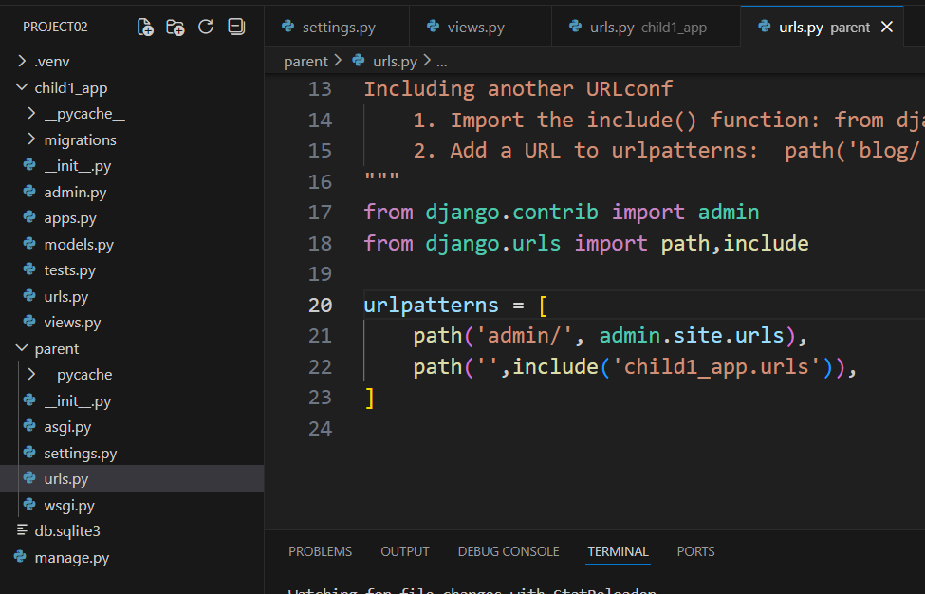
(myvenv) PS D:\NG_4.O_SRU\day-09\project01> python manage.py runserver
DAY -10 (30/1/26)
Absent
DAY -11 (31/1/26)
Static way of img upload into the project
Creating the blocks of code to reduse the reputation of the code in all the files (eg: nav bar section)
Creation of base.html
--
1. In myapp write the code in models.py(table creation)
2. write code in myapp\admin.py
```
# Register your models here.
from .import models

admin.site.register(models.User)
```
3. Run the comments
--------------

(myvenv) PS D:\NG_4.O_SRU\day-11\project02> python manage.py makemigrations
Migrations for 'myapp':
myapp\migrations\0001_initial.py
+ Create model User
(myvenv) PS D:\NG_4.O_SRU\day-11\project02> python manage.py migrate
Operations to perform:
Apply all migrations: admin, auth, contenttypes, myapp, sessions
Running migrations:
Applying contenttypes.0001_initial... OK
Applying auth.0001_initial... OK
Applying admin.0001_initial... OK
Applying admin.0002_logentry_remove_auto_add... OK
Applying admin.0003_logentry_add_action_flag_choices... OK
Applying contenttypes.0002_remove_content_type_name... OK
Applying auth.0002_alter_permission_name_max_length... OK
Applying auth.0004_alter_user_username_opts... OK
Applying auth.0005_alter_user_last_login_null... OK
Applying auth.0006_require_contenttypes_0002... OK
Applying auth.0007_alter_validators_add_error_messages... OK
Applying auth.0008_alter_user_username_max_length... OK
Applying auth.0009_alter_user_last_name_max_length... OK
Applying auth.0010_alter_group_name_max_length... OK
Applying auth.0012_alter_user_first_name_max_length... OK
Applying myapp.0001_initial... OK
Applying sessions.0001_initial... OK
(myvenv) PS D:\NG_4.O_SRU\day-11\project02> python manage.py createsuperuser
Username (leave blank to use 'user'): admin
Email address: not needed
Password:
Password (again): N@1234
This password is too short. It must contain at least 8 characters.
Bypass password validation and create user anyway? [y/N]: y
Superuser created successfully.
(myvenv) PS D:\NG_4.O_SRU\day-11\project02> python manage.py runserver
4. In the url add the /admin (u can see the tables)
5. Edit myapp/views.py
https://github.com/sarwarbabamdGit/Django_Login_Register_Home.git whole code in this

DAY -12 (2/2/26)
Python
Project start

DAY -13 (3/2/26)

Project review

ORM (object relational mapping)db independent
Code is written in the py (ORM will convert in to py to sql )

In sql--------------------in Django
Table --------------------model
Column/attribute------field
Row/tuple -------------Object

DAY -14 (4/2/26)
Project review

DAY -15 (5/2/26)
Project review

DAY -16 (6/2/26)
Project review with EY

DAY -17 (7/2/26)
Absent

pip install google-genai
send in what’s app
REST Api

A **small API** that:

* Saves text
* Returns saved text

You will test it using **browser or Postman**.

---

# Step 1: Install

pip install django djangorestframework
```

---

# Step 2: Create Project & App

django-admin startproject demo
cd demo
python manage.py startapp api
```

---

# Step 3: Add Apps (settings.py)

```python
INSTALLED_APPS = [
'django.contrib.admin',
'django.contrib.auth',
'django.contrib.contenttypes',
'django.contrib.sessions',
'django.contrib.messages',
'django.contrib.staticfiles',

'rest_framework',
'api',
]
```

---

# Step 4: Create Model (Database)

**api/models.py**

```python
from django.db import models

class Message(models.Model):
text = models.CharField(max_length=100)

def __str__(self):
return self.text
```

python manage.py makemigrations
python manage.py migrate
```

---

# Step 5: Create Serializer (IMPORTANT)

Serializer converts:

```
Python object ⇄ JSON
```

**api/serializers.py**

```python
from rest_framework import serializers
from .models import Message

class MessageSerializer(serializers.ModelSerializer):
class Meta:
model = Message
fields = '__all__'
```

---

# Step 6: Create API View

**api/views.py**

```python
from rest_framework.decorators import api_view
from rest_framework.response import Response
from .models import Message
from .serializers import MessageSerializer

@api_view(['GET', 'POST'])
def message_api(request):

# GET → show data
if request.method == 'GET':
data = Message.objects.all()
serializer = MessageSerializer(data, many=True)
return Response(serializer.data)

# POST → save data
if request.method == 'POST':
serializer = MessageSerializer(data=request.data)
if serializer.is_valid():
serializer.save()
return Response(serializer.data)
```

---

# Step 7: URLs

**api/urls.py**

```python
from django.urls import path
from .views import message_api

urlpatterns = [
path('messages/', message_api),
]
```

**demo/urls.py**

```python
from django.urls import path, include

urlpatterns = [
path('api/', include('api.urls')),
]
```

---

# Step 8: Run Server

python manage.py runserver
```

---

# Step 9: Test in Browser (GET)

Open browser:

```
http://127.0.0.1:8000/api/messages/
```

You will see:

```json
[]
```

---

# Step 10: Test Using Postman (POST)

1. Open **Postman**
2. Method → **POST**
3. URL:

```
http://127.0.0.1:8000/api/messages/
```
4. Body → raw → JSON

```json
{
"text": "Hello REST"
}
```

5. Click **Send**

Response:

```json
{
"id": 1,
"text": "Hello REST"
}
```

---

# Step 11: Test GET Again

Refresh browser or Postman GET:

```json
[
{
"id": 1,
"text": "Hello REST"
}
]
```

---

# That’s It 🎉

You just created:

* A **REST API**
* With **Django REST Framework**
* No HTML
* No templates
* No JavaScript

---

# Remember This (Beginner Gold Line)

> **DRF = Django + JSON + API**

AI Skills Passport

'Intelligence' refers to the ability to learn, adapt, improve, and perform tasks such as reasoning, problem-solving, comprehending, and decision-making. The word 'Artificial' refers to the fact that it is man-made.

AI is a field of computer science which focuses on creating machine systems capable of doing things, like problem solving, which would typically require human intelligence.

AI is often categorized into two groups:
1. Narrow AI: Also known as Weak AI, these are systems designed to execute a specific task, or tasks;
2. General AI: strong AI, capable of performing any task that requires cognition and intelligence
does not exist, except maybe in sci-fi movies., General AI is different from Generative AI; Generative AI is a form of Narrow AI.

some people agree on a third category, Super AI. as Super AI is still a long, long way away.

